Atco interview

Environmental Science project by Annelies Bakker, Kim Balcera, Yaella Lopez. November 26, 2017



The main guidelines for this interview were the following:

* Personal and professional impressions of waste management in Aruba
* Desired future of waste management in Aruba
* Obstacles seen in getting to this desired future scenario
* Market for improved waste management in Aruba (who would pay for better waste management in Aruba? (e.g. recycling)

The interview was a semi-structured interview with open ended questions, thankfully there was a dialogue going on during the interview making it easier to understand everything a bit better, and gave way to asking random questions during the interview.

The Interviewees name is **Ramsey Halabi, Managing Director of Ecotech.**

**Interviewer: how does ATCO manage their waste?**

**Interviewee:**

ATCO is a sister company of Ecotech. So, their construction waste or just regular waste goes to Ecotech which ends up in Ecogas. It's about organizing. It's about structure. Do you guys see that at first, it's a chaos, trash just comes in as it is, in its raw form?

But then you see that it gets organized. Different types of waste get separated. Little bit goes in a bin, the ones that we can't process goes to one side. Once it enters the plantation you can see that theirs is an organization. Everything ends up nicely piled up in a trailer. So, there is no chaos, it is not disorganized. That makes the process go well because then you can come up with alternatives. Those packages (the RDF's, Refuse-Derived Fuel) must end up in a hole(landfilling), but it can also be shipped to a cement plantation.

Yes, it's a cost. I contacted Cemex and Cementos Argos which are two big cement companies in the region and they can use that product instead of carbon in their plantation. They get carbon for maybe, 50$ per ton, but this product's energy value is more or less half of the carbon. But it can be used. I asked them if they are willing to work together and they said yes, they are willing. First thing they said was they needed to get the product tested if it is safe enough to import to Colombia. So, they sent a group of scientists to come and test the waste. They tested it for corrosive, reactive, inflammability, toxic, explosivity and I don't remember the last one.

The test came out positive so that means that it is okay. So, I know that this product is safe to import and export so, I can put it in a hole too because it's carbon based. If I can take it from the ground, I can put it back in the ground. People will say "No this is not good because plastic is toxic" this is not true. Plastic is made out of oil. The only plastic that are toxic are PVC and electronic plastic but we take those out. We should play close attention to those when managing waste. What makes something toxic? The quantity, the concentration and the heavy metals. But our plantation takes out the heavy metals. So, you will not find that in those packages. So, that in a nutshell what we do.

**Interviewer**: regarding your desired future for the waste management in Aruba, do you see any obstacles or barriers that prevents achieving those goals?

**Interviewee:** Of course, there are. There's plenty of them. Look, it’s a political decision. For those waste to end up here, it's going to be a political decision. Someone in the government has to decide to let the trash end up here. But why won't they make the decision? Because there's Serlimar, labor union, and other different things that are at stake. It's very difficult. Working together is not going to happen. Not that we don't want to, it's because the private sector and the public sector is difficult to work with.

**Interviewer: Can you explain to us the whole process of what happens to the waste?**

When the waste is dumped on the floor, the cleaning operator stars sorting. If he see’s a washing machine, stove or fridge etc, he’ll put it in a bucket and send it to Deltra or Carentra, as one of our partners in recycling, who are responsible for getting rid of metals and non-metals. Further, the crane dumps the waste into a primary shredder, and shreds it down into sizes of 25 cm and smaller so it can be handled better. Later it goes into what we call out ‘trommel’, which separates the waste into 3 different fractions from 0 to 80, 80 to 250, and 250+ fractions. Each size is then separated with a magnet or any current system. The three fractions we take out are aluminum with metals, sand, rocks and stones, and then some organics in that pile. The rest is all carbon based, so plastic, fibers, textile, cardboard, paper, which is what we call RDF (refuse-derived fuel), which is all the material that burns. It produces calorific value. The material is then reduced by 80% more or less, it is bagged, put in trailers, and we find a partner that for example does excavations for granites on the island, and has a pit. And we fill the pit up and then cover it so the place can still be used for something else, like a recreational area or anything. There are about 40 to 50 pits on the island so there is ample space for the next 20 to 25 years for waste management. Later on we have to find an alternative.

Meanwhile were working on the separation, it switches to another process that we have, and that’s the gas part, where we produce gas from that material. But that part is on hold right now because we are still in negotiation with W.E.B.

**It was asked if more pits should be added on the island,?** and the **interviewee** says that nobody wants to make more pits. He suggests to use the ones we have and not to dig more.

He says that in 2009 they started with recycling. But he also said that recycling only scratches the surface with what you take out, and the products that you get don’t have enough value to make the business feasible. And explained that they were doing cardboard, were they picked up cardboard in different places around the island. They sent trucks with a driver and a helper with enough fuel, they had to maintain that truck, run around the island and pick up the cardboard, bring it in, clean it with 2 other people since people are not educated on how to properly recycle. And then store it with a work lift in the container, take it to the port. He said that every one of these things adds dollars to it. They then put it on a ship and sent it Taiwan, which is another cost, truck it again to the mill where they’d have to actually pay for them to take the container and get rid of the cardboard. All in all he said recycling on an island is very difficult because of all these steps, compared to for example Europe or the US.

He also mentioned that they one thing they have to educate people about is that conventional recycling does not work on an island. We can talk about recycling on an island, but it has to be extremely efficient on an island. He’s not saying no to recycling, since there are always ways to do it, but a lot of people need to be very involved to make it happen. For example, he can skip a few steps by telling people he’ll put a bailer outside, and people can come with their cardboard and put it in, make sure its clean, press the button, and all he does is take the bail out and put it in the container. He says it may work, but it will still be difficult. People have to be disciplined enough to bring the proper material, and that’s with cardboard.

**Interviewee:** Me as a, as a waste processor, I, we need to send a truck for each container cause I cannot pick all containers together or else they will get mixed, you understand? So all that works against recycling. Because if it was in the states or Europe, ok on Monday we pick up OCC, that bucket of OCC that is outside. On Tuesday we pick up eeh plastic, that bucket is outside, on Wednesday we pick up aluminum, on Thursday metals, and on Friday another thing. So it can work, regular garbage for example on, on Friday, but in in in a conve.. you know on a island it makes, you know everything is exponentially more expensive, **Interviewer:** Yes.

**Next question: Interviewer is there an proposal / new way of recycling?**

**Interviewee:** well that what, why I, I have a project in my hands, what to do, maybe I am gonna do something with start recycling centers, for example a superfood, or a supermarket will become a recycling center, where where, people go to that place, and we, we centralize where it’s going, and see if that supermarket or recycling center is willing to become a material recovery facility where, you know, we can go and collect, bundles of things. So we it makes, we skip a couple of steps, you understand? I**nterviewer:** Ok. **Interviewee:** That’s is one way of looking at it, but back tracking back to what we did and why recycling doesn’t work we have to think a little outside the box, what haap, what what to do, so we said what, were not gonna continue recycling abroad we’re gonna try to do something locally, then we are at this point where we have all this material. We said what can we do with that material, well we can convert it to gas, it means you need to come up with a certain type of plant that can convert that material to gas, and in 2013 we decided to go with that project, we talked with W.E.B, we said you know what, we are gonna produce gas are you willing to accept it, we agreed, they said well you got to comply to this and this and this, and your gas, we asked our supplier , our supplier said uhm , yes I can deliver that uhm. And then uhm uhm uhm , we decided to order these machines, when the machines came on the island, we realized they were not doing what they were supposed to be doing uhm, they weren’t reliable, things were breaking because these are very very, these machines work in extreme temperatures, I mean were talking temperatures were everything would melt, so we had failures in metals , we had failures in, everywhere that you can expect failures, we had failures. So we parted ways with the supplier, we said , you know what, stay out, we will, knowing us, were a company that is usually is aggressive in that nature. We called engineers from the US, we called engineers from Europe uhm uhm Holland and we build a team together with locals, and we made the plant work. We produced the gas with the material we ran the gasifier, we produced gas, we pumped the gas all the way to the powerplant, the powerplant ran the motor, the motor produced electricity, and then we came at an point that we had to do a test to comply to the contract, aaand that is were we got stuck, cause one of the items that we agreed upon 4 years before was out of step. And based on that we stopped, because they expect us, the want us to take that out or reduce it, we say no we we , we have invested quite enough already and we don’t see the need why to take it out, it’s a component we call H2S hydrosulfite, which is very toxic, but carbon monoxide is also very toxic, right? **Interviewer** :Yes. where does carbon monoxide come from? Where do you find carbon monoxide, very basic ? **Group answer**: Cars**, Interviewee** , Uitlaatgas. U take a a, don’t do this, u take a hose and put it in your car through the muffler You will die, no exemptions. You will die, Its toxic , its lethal, so H2s is the same thing, you have it in an environment well, where the concentration is high enough , it will kill you**. Interviewer:** but between the two of them, which is more dangerous? Are they equally dangerous? **Interviewee:** there equally dangerous. What makes a poison? **Interviewer:** the toxins, that it can bring to you**, Interviewee:** what makes a poison and there is an easy answer to that. It’s the dose, The dose makes the poison, Everything is toxic. **Interviewer** , Its just how much you make of it, how much you take of it, that will kill you. Water will kill you if you drink too much of it, you know, They call it the dose, makes the poison. That’s why when you do a toxicology report when when, someone overdoses they do a toxicology report to see much of that they took. You know if he took drugs, they will do a toxicology report of how much he took in order to say, ok he had this much of him in his body and that’s what killed him, so, its not the component that kills you, it’s the amount of it that kills you. And that’s very important because in a process of, of course in a process you have dangerous things. In the refinery you have H2S running at a 100%. We’re talking ppm’s ,250 ppm’s which is about a million times smaller than the, the, the refinery operates with, and yet they don’t have a problem, but we have a problem here, it’s a peoples issue, its an understanding issue, so that’s where we stopped .We didn’t , and then you hear a lot of things in the media, you guys probably heard, Ecogas failed, they came up with a solution that never worked, that everybody paid for an investment for W.E.B that never worked, all that was the negative news that came in the media, which is not really ok, cause the line that they drew, you the line that they drew for us with the gas, that line is ready for when they switch over to natural gas, they just have to pipe it to the port and there done. It’s an investment made van te voren. The conversion from that boiler that they made for gas, same thing, it’s ready for when they jump to natural gas, so it’s no investment that, you know is gonna be lost, they will use it. But again, there are options, we’re still negotiating , none of this was in public, cause we have non disclosures with W.E.B. We can not disclose certain things and that is why we never went public. Those discussions are ongoing, and we think probably next year, we will come up to a solution. And we will see if that’s one way of, that will be an alternatives to the solutions that we are already practicing, so if the gas works, then the land reclaiming will be probably , partial land reclaiming, and partial gas. So your still juggling in between.

**Interviewer: Who would pay for the better waste management in Aruba, and who has paid for that? Interviewee**: I think the people, I Think the people have to understand that waste management ,responsible waste management will cost. The government will not have to pay for it, do you think so? **Interviewer:** well if they raises taxes or anything, it will come from the people anyways, Interviewee , yeah, its about the funds, Whoever, If you come with the funds, waste management will come, but if there is no fund how can you manage without funds, , the government need to step up and say, somebody needs to do a study about how much it’s gonna cost, we have an idea of how much it’s gonna cost. The 26 guilders, is basically for collection, there is nothing available for the processing. So we’re thinking, for example a household will produce about a ton of waste a year, 1 ton. Right now a ton of waste costs, for processing cost about 60 guilders, so its needs to be, so that about 60 divided by 12 is about 5 guilders, but it needs to be close to 1.50, 1.60, so your talking about 10 to twelve guilders a month for waste processing, you think it’s not a lot, but people on a minimal wage, you know, it weighs it weighs a lot. So, but, but, you got to think about those people, that are gonna be huiverig , to pay that. But there is got to be a law that everyone pays for waste, that is the only way we can get out of this mess.

**Interviewer**: What do you think about waste management from a personal point of view? and I think its not a fair question because I will always say, if you ask me, I say, it’s its’s Ill give a biased answer, because I always yes I do a good job, doing waste management, I’m not gonna say I do a lousy job, then you gonna ask me what I think about how the island, how it manages waste , and then I’ll have to say well there is a lot that can be improved. **Interviewee:** Do you think you handle waste responsibly, **Interviewer:** honestly no, **Interviewee:** no, why not? You throw away things in the trash right? So your responsible, you don’t throw it from the window of the car? **Interviewer**: no**, Interviewee:** so it goes in the trash, but is that still responsible? I mean if you say your house is clean, you can say hey , I’m a responsible e e eh eh, I’m responsible I throw everything in the trash, but is that still responsible. **Interviewer:** no cause your still producing a lot of trash. **Interviewee:** yes, is that trash really trash?, I’m not talking about recycling yet, I’m talking about, I’m just giving that analogy**,** food waste, do we throw food in the trash? I mean it can be used for compost, gardening , for your dogs , whatever, uhm, that’s one example, if you have milk in your fridge and you know you have a half, half empty container, and it spoils, do you throw, how do you dispose it ? you throw it in the trash?, you throw it in the drain, how many do that? Some people will smell it, in the trash, so we get halve a container in the floor, ready to be thrown, or my process, that’s were the smell comes from, its not that we wanted the place to smell, it smell because of the way we manage waste at home, that’s one way of thinking. Separations, the plastics and everything’s the plastics are some bags with plastic will go to vendors and will be used for capping, the RDF will go to the gas plant……, so I guess you guys wanna see the plant? let’s go.

**The following are pictures taken from the 7 step process as depicted in the office:**

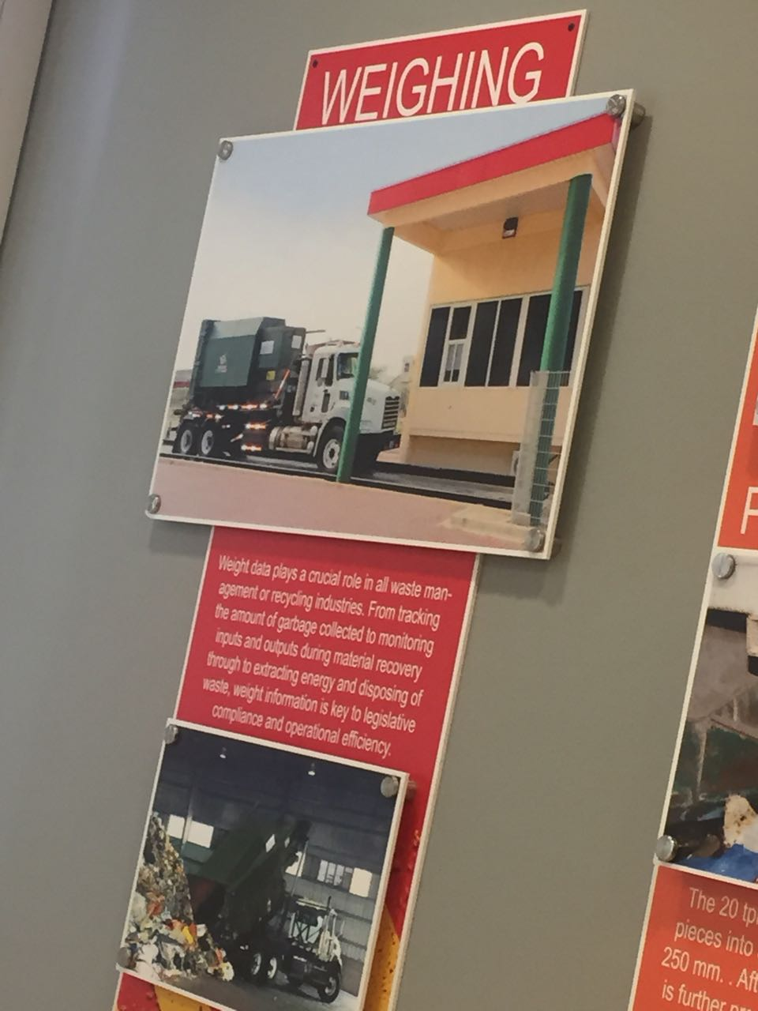

**Step 1 - The weighing**

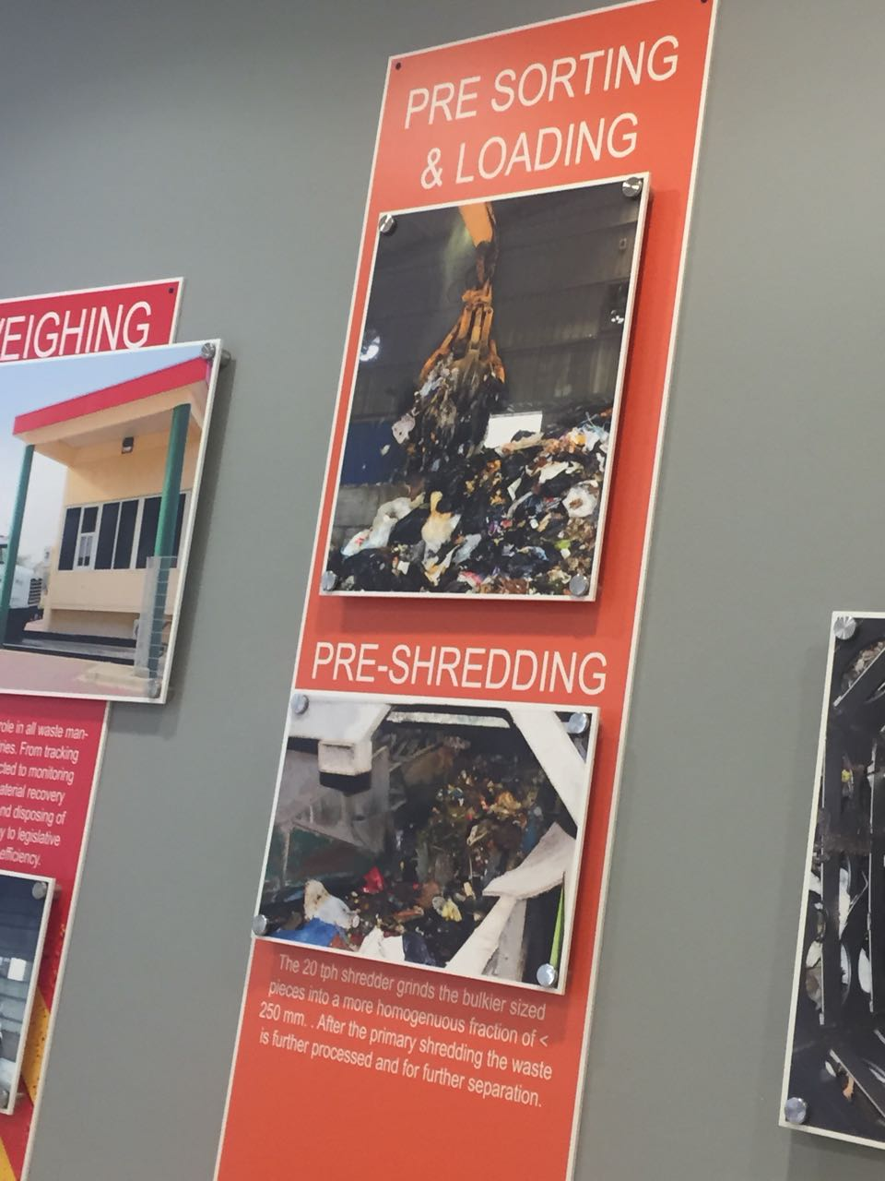

**Step 2 - Pre-sorting & loading – Pre-shredding**

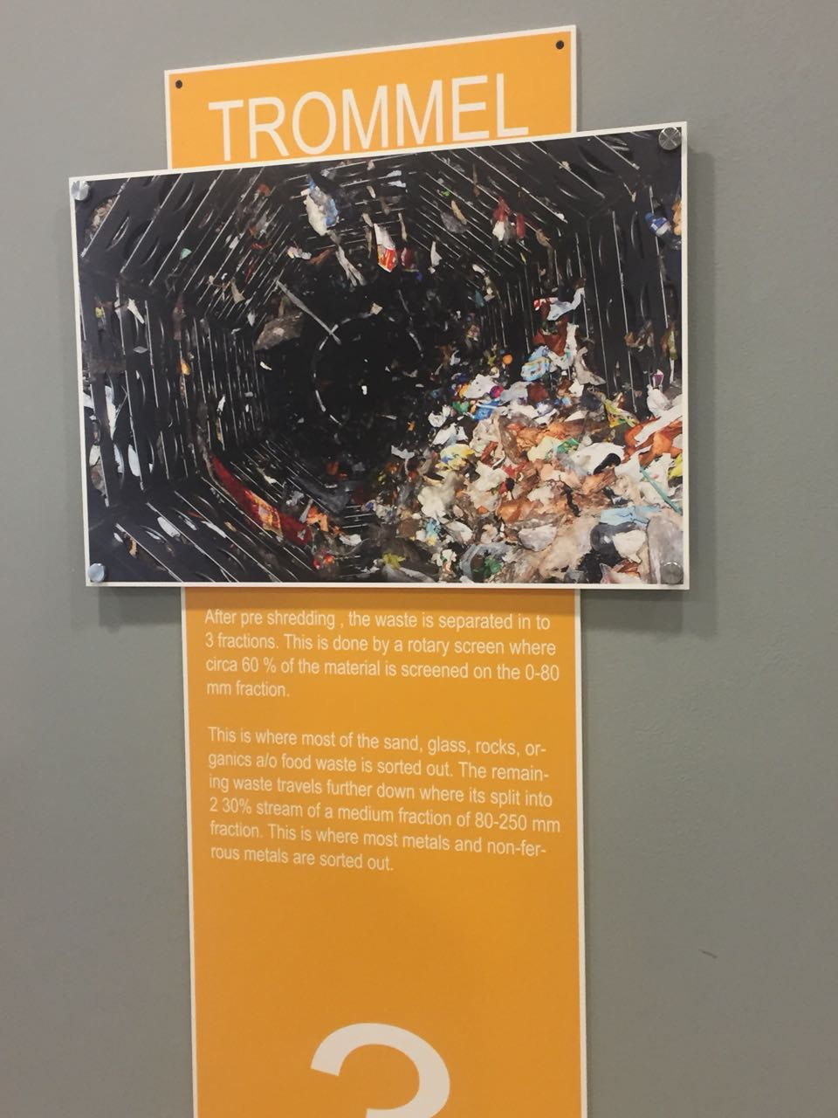

**Step 3 - The Trommel / Separator**

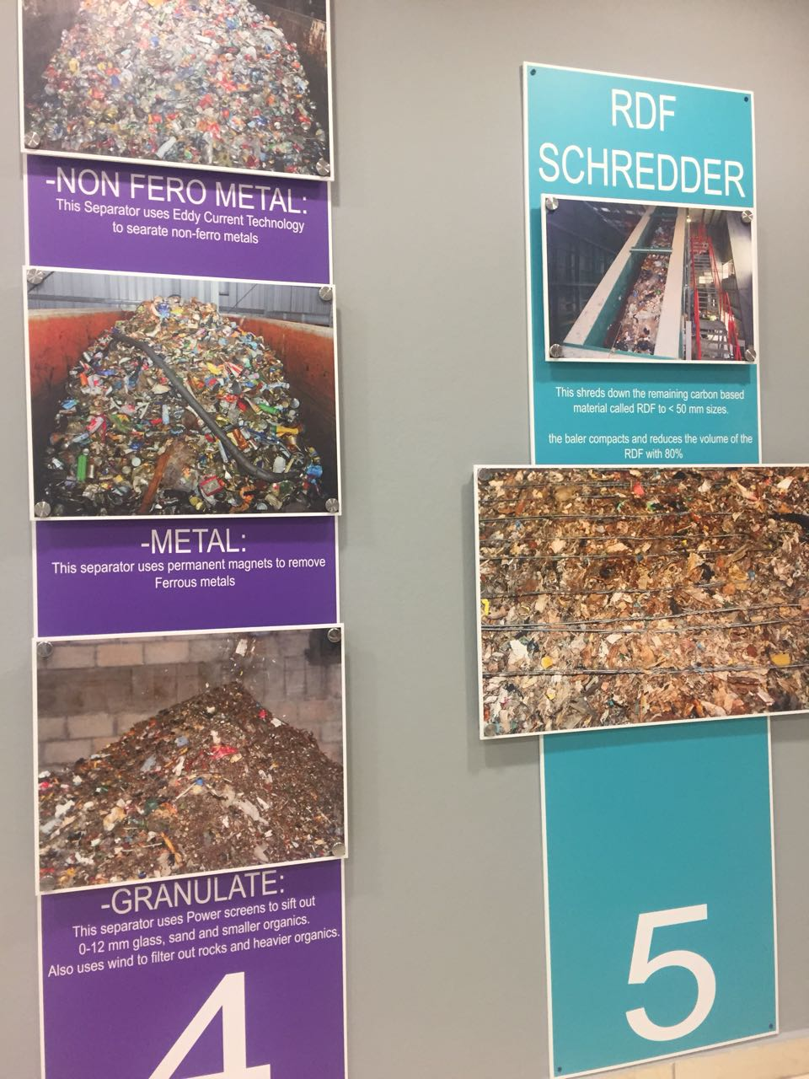

**Step 4 -The three Fractions of separation, Step 5 - the RDF shredder**

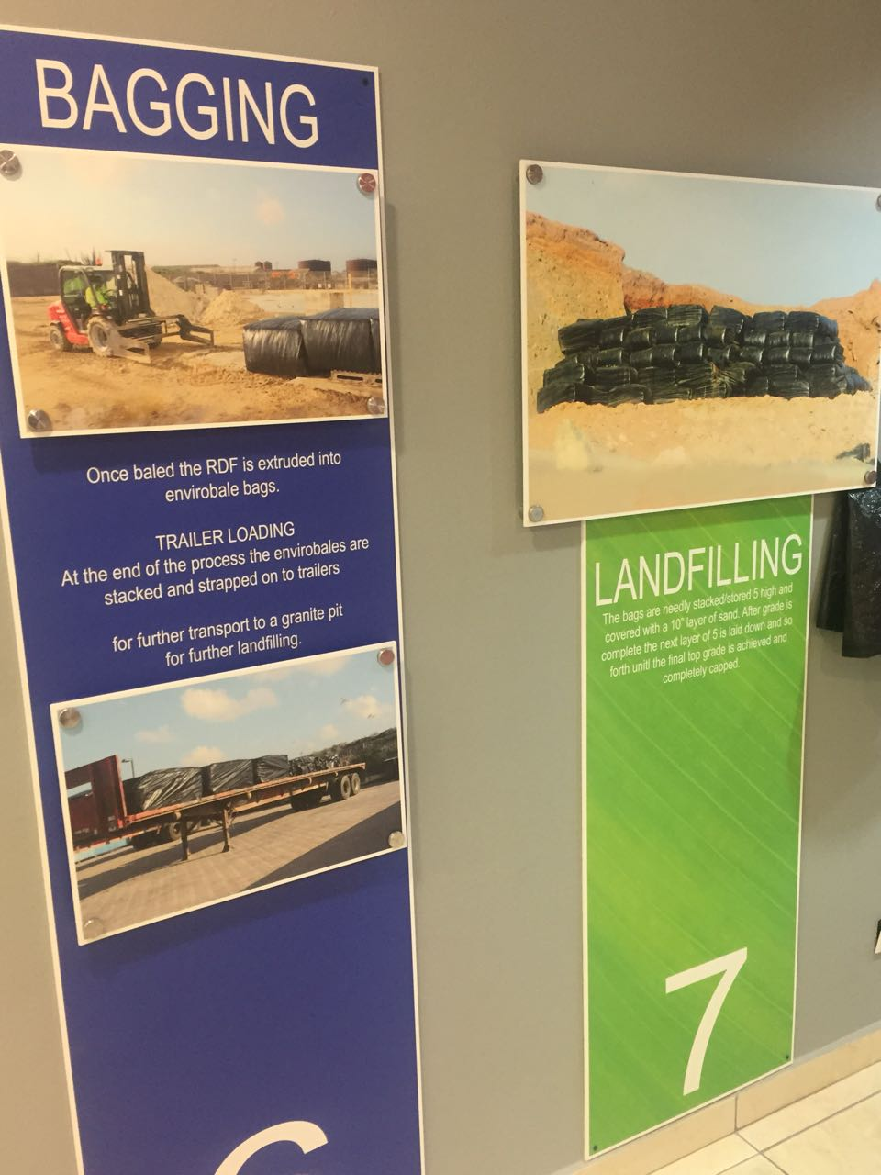

**Step 6 – Bagging, Step 7 - Landfilling**

**Interviewee’s perspective on the subject,**

The perspective was clearly recognizable during the interview.

Mr. Ramsey seems like a good person (heard for his concern for the minimum waged and the values he has about waste management) that does take sustainability and recycling to heart, but due to the setbacks some of his goals couldn’t be reached. Yet he seems optimistic of the future plans of waste management in relation to the current ways on the island. In the interview he mentioned that and we quote: **“I have a project in my hands, what to do, maybe I am gonna do something with start recycling centers for example a superfood, or a supermarket will become a recycling center, where where, people go to that place, and we, we centralize where it’s going, and see if that supermarket or recycling center is willing to become a material recovery facility where, you know, we can go and collect, bundles of things.”**

In general the feeling, and the words that he used in the interview he expressed frustration about the policies instated by W.E.B and also the limited capabilities and obstructions that exist for recycling on the island.

He expresses the negative news in the media about Ecogas and W.E.B and how it has affected them.

He is also clearly stated that he is biased during the interview as he stated and we quote: **“What do you think about waste management from a personal point of view? and I think it’s not a fair question because I will always say, if you ask me, I say, it’s its’s Ill give a biased answer, because I always yes I do a good job, doing waste management, I’m not gonna say I do a lousy job, then you gonna ask me what I think about how the island, how it manages waste , and then I’ll have to say well there is a lot that can be improved.”**

Overall the interviewee didn’t seem optimistic about recycling on the island, whether it be a budget aspect or the bureaucratic guidelines that enables him from following through on certain projects**.**

He also indicated that he thinks that the government should instate more waste related laws such as waste taxes.

The tone of the interviewee was slightly defensive and one could hear frustration in his speech. although he was very polite in answering all questions given to him.

Mr. Ramsey clearly knew what he was talking about, as he could name various components of trash, the process, prices, and including deep insight on the current procedures happening on the island. He showed that he is very much involved in the company, and after analysis of Mr. Ramsey it was clear that he has a lot of experience in the industry.